**Lab-02**

**Java Programming Elements**

## Objectives:

Learning Input / Output handling on Java console. Understanding variables using primitive and non-primitive data types. Exploring Java’s built in classes.

**Theory:**

**Console input**

System.in to the standard input device. Console input is not directly supported in Java, but Scanner class is used to create an object to read input from System.in, as follows:

Scanner input = new Scanner(System.in);

double radius = input.nextDouble();  
Import the class by adding

import java.util.Scanner;

**Console output**

Java uses System.out to refer to the standard output device.To perform console output, println method is used to display a primitive value or a string to the console.

System.out.print("Hello ");

System.out.println("world");

You can use the System.out.printf method to display formatted output on the console.

System.out.printf(“Your Total amount is %.2f", total);

System.out.printf("count is %d and amount is %f", count, amount);

**Data Types in Java**

A data type in a programming language is a set of data with values having predefined characteristics.

There are two basic types in Java.

1. **Primitive**  
    A primitive type is predefined by the language and is named by a reserved keyword.
2. **Non-Primitive**

It is a reference data type, which are references to objects.

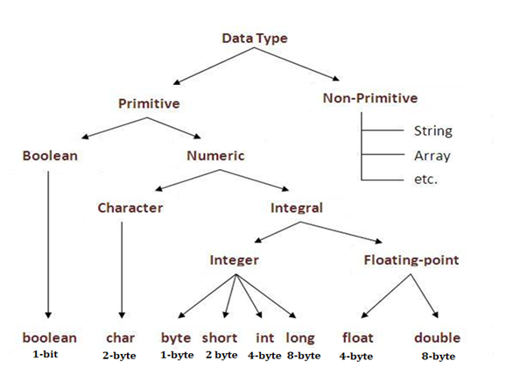

Figure 2.1: Data Types in Java

**Variables**

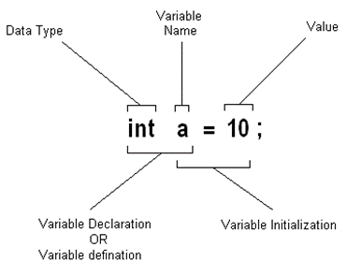

Figure 2.2: Variable Initialization

* Variable is a name of memory location.
* It is name of reserved area allocated in memory.
* In the given example; int is data type, a is variable name
* and 10 is the value that a variable holds, followed by a terminator;

**Type Conversion**

Casting is an operation that converts a value of one data type into a value of another data type. The syntax for casting a type is to specify the target type in parentheses, followed by the variable’s name or the value to be cast. For example;

System.out.println((int)1.7);

The above statement displays 1. When a double value is cast into an int value, the fractional part is truncated.

**Some Useful Java Classes**

**Math**

Math class file is included for the definitions of math functions listed below. It is written as java.lang.Math.

Trignometic / Maths Functions

|  |  |
| --- | --- |
| * sin(n) * cos(n) * tan(n) * sinh(n) | * hosh(n) * tanh(n) * pow(nmb,pwr) * sqrt(n) |

**Lab Task:**

1. Design a Java program to take different input from user and store the input in variables with respective data type and then display the data on the console.
2. Design a Java program to explore Math class.

**Lab Assignment:**

**Program the following.**

Implement the following equation

3x4sin(180x) + 4x3cos(90x) + x2sin(tan(45)) + 7x + 9cos(90x2 )

Where x may be user defined value.

**Conclusion:**

___________________________________________________________________________________________________________________________________________________________________________________________________________________________________________________________________________________________________________________________________________________________________________________________________